

**Geometric Camera Calibration Report**

**UAV Oblique Camera System**

**CA502R SN:CA502R202115**

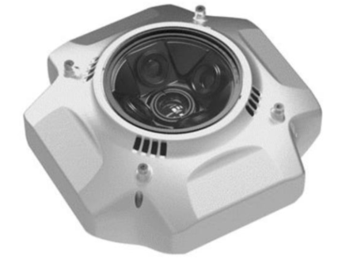

Issued by

Faculty of Engineering, Chulalongkorn University

254 Phayathai Road, Wangmai, Patumwan, Bangkok 10330

For

Systronics (Thailand) Company Limited

615 Charansanitwong Road 615,

Bangor, Bang Phlat, Bangkok 10700

15 December 2022

เอกสารนี้เป็นส่วนหนึ่งของ

โครงวิจัย การศึกษาการจัดทําจุดเป้าบังคับบนพื้นดินสําหรับยูเอวีเลเซอร์สแกน เลขที่ 001/2565 ลงวันที่ 1 สิงหาคม 2565 ของคณะวิศวกรรมศาสตร์ จุฬาลงกรณ์มหาวิทยาลัย ประจําปี 2564

S

X

D

A

W

**Traceability**

This calibration report documents the International System of Units (SI) and calibration procedures of the 5-camera rig system. The 5-camera comprises a centered ‘NADIR’ camera and the other four rigged oblique-camera, namely ‘FRONT’, ‘REAR’, ‘LEFT’, and ‘RIGHT’. Providing rig parameters relative to the ‘nadir’ camera from the manufacturer, four translations were constrained with a weight of 5 millimeters and the Euler’s rotations were weight with 5 degrees. In the calibration field, 48 ground control points (GCP) and checkpoints (CP) were erected and accurately measured by GNSS RTK with 3.5- and 6.5-centimeter accuracy for the horizontal and vertical components. The parameters f, cx, cy, R1, R2, R3, T1, and T2 have opted for camera modeling. All photogrammetric measurements for tie-points were accomplished by Pix4D mapper software and GCP and CP points were measured by visual marking. Then all parameters and unknowns were solved simultaneously together with the aforementioned constraints. All uncertainty criterions are empirically defined from long-term observations.

**Phisan Santitamnont (Dr.-Ing)**

**Thirawat Bannakulpiphat (M.Eng.)**

**Photogrammetric Block Information**

|  |  |
| --- | --- |
| **Photogrammetrist**  **UAV Camera Operator** | 1. Phisan Santitamnont (Dr.-Ing) 2. Thirawat Bannakulpiphat (M.Eng.) 3. Jakkrapong Puntho |
| **Flight Date and Time** | 05/11/2022 (After 12.00 PM.) |
| **Report Date / Release** | 12/12/2022 |
| **Test Field** | Geodetic GNSS and UAV Testing Field, Chulalongkorn University |
| **Location** | Saraburi, Thailand (Latitude: 14°.5236N, Longitude: 101°.0235E) |
| **Aircraft** | JOUAV CW-15 |
| **Camera** | CA502-R 120MP |
| **Block Name** | Small block CU-SBR |
| **Number of Photo** | 6,065 (1,213 photo per camera) |
| **Nadir Photo Overlap (%)** | 80% |
| **Nadir Photo Side-lap (%)** | 80% |
| **Number of Rig Station** | 1,213 |
| **Number of Flight-Strip** | 27 |
| **Number of GCP/CP** | Total 48 |
| **Photogrammetric Processing Software** | Pix4D Mapper version 4.7.5 |

**Camera Specification**

|  |  |
| --- | --- |
| **Parameter** | **Description** |
| Number of CCD | 5 pcs |
| CMOS Size | 23.5 × 15.6 mm (APS-C) |
| Pixel | 24 MP x 5 |
| Resolution (Single CCD) | 6000 x 4000 |
| Exposure Interval | 0.8 s |
| Type of Lens | Aspheric |
| Focal Length (Ortho/Oblique) | 28 mm/43 mm |
| Weight | 950 g |
| Damping Structure | Internal |
| Power Supply | External |
| Data Storage | 5 x 128 GB SD Card |

**Quality Report**

1. **Camera position from manufacturer note**

|  |  |  |  |  |
| --- | --- | --- | --- | --- |
| **Camera** | **X (mm)** | **Y (mm)** | **Z (mm)** | **Camera** |
| **CA502R** | +30.00 | -425.00 | -229.38 | Ortho view |
| +30.00 | -476.48 | -251.56 | Left view |
| +30.00 | -373.86 | -251.26 | Right view |
| +81.14 | -425.00 | -251.26 | Forward view |
| -21.14 | -425.00 | -251.26 | Backward view |

1. **Initial and adjusted rig relative parameters**

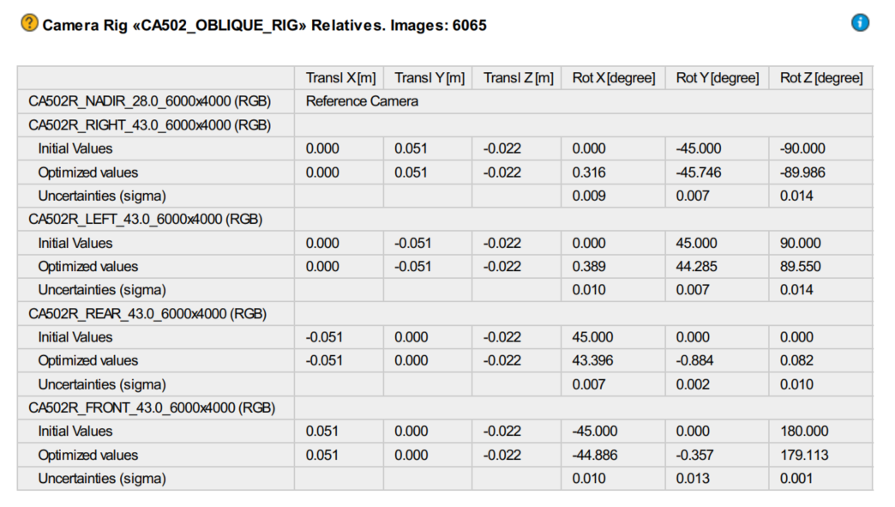

**Evaluation result passed:**

|  |  |  |  |  |
| --- | --- | --- | --- | --- |
| **Uncertainty** | **Tx, Ty, Tz (mm)** | **Rot X (degrees)** | **Rot Y (degrees)** | **Rot Z (degrees)** |
| Criterion | Constraint | 0.015 | 0.015 | 0.015 |
| Passed | Badge Tick1 with solid fill | Badge Tick1 with solid fill | Badge Tick1 with solid fill | Badge Tick1 with solid fill |

W

X

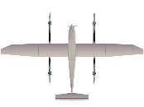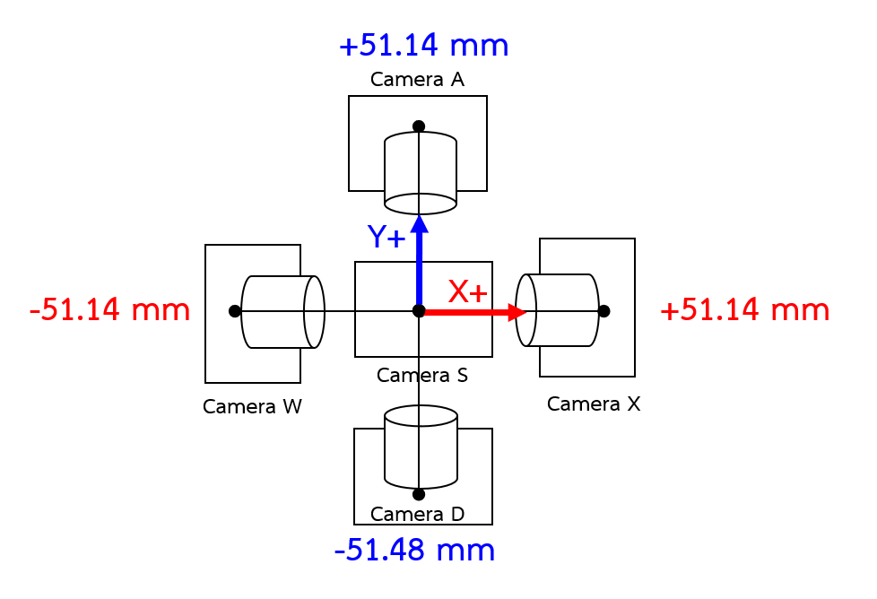

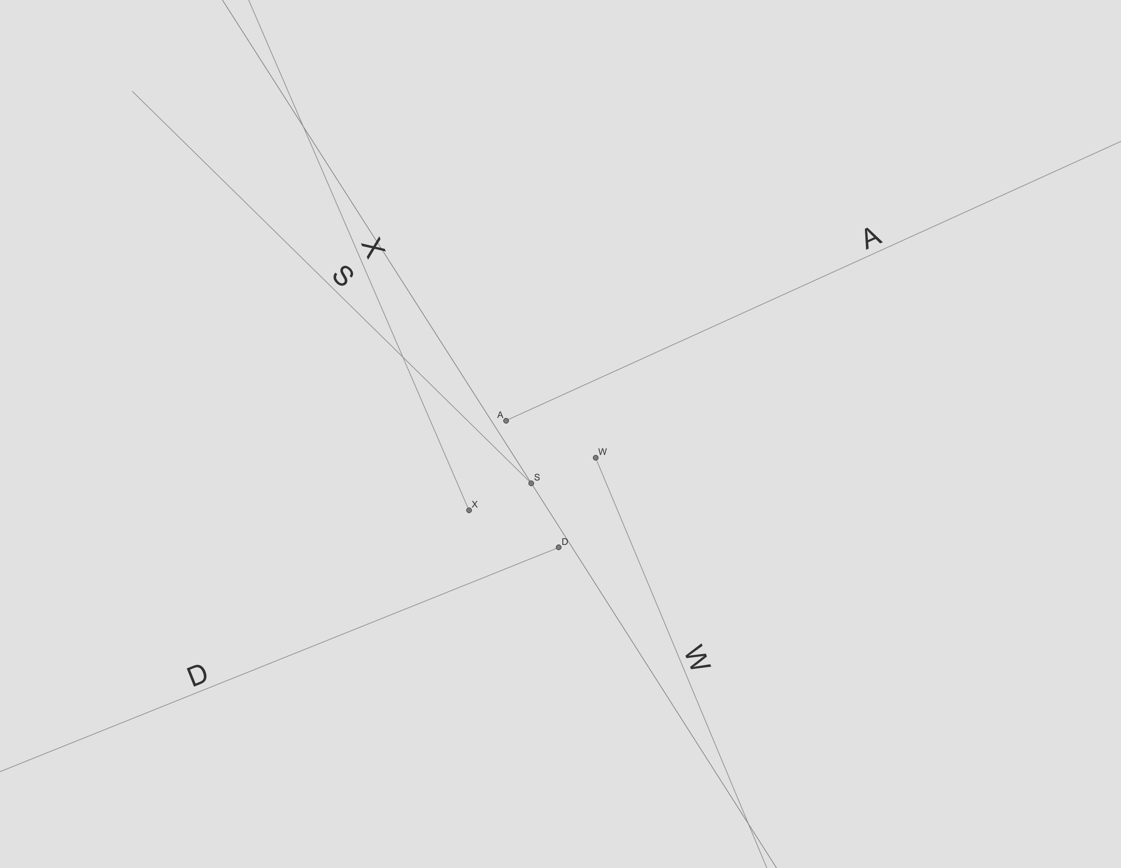

1. **Internal Camera Parameter**

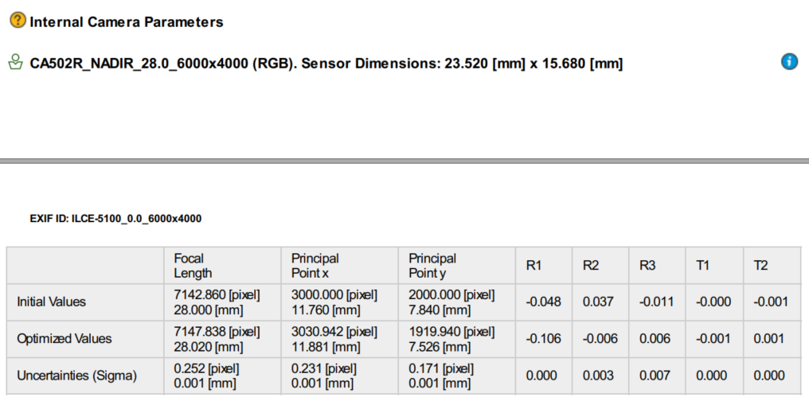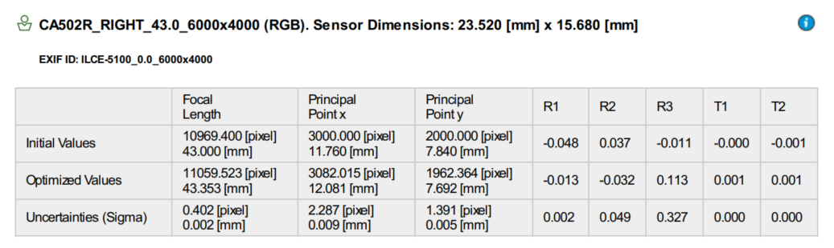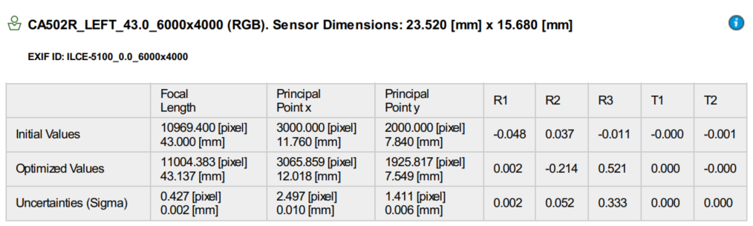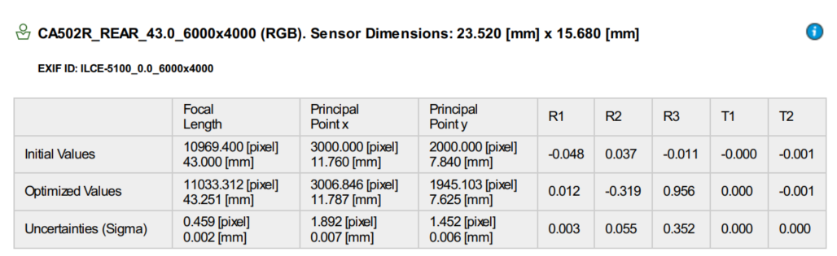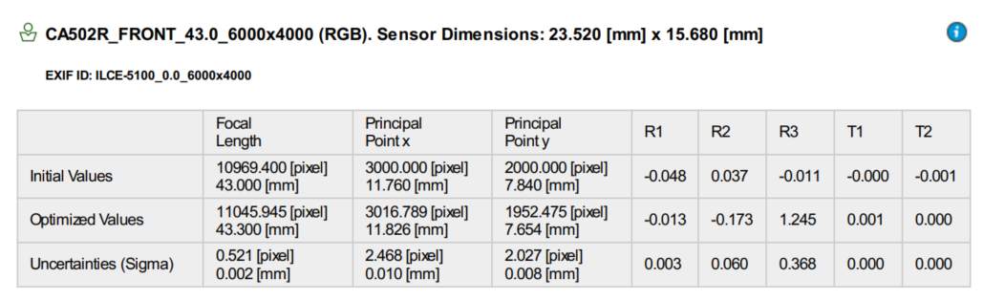

**Evaluation Results Passed:**

|  |  |  |  |  |  |  |
| --- | --- | --- | --- | --- | --- | --- |
|  | **f** | **cx** | **cy** | **R1** | **R2** | **R3** |
| Criterion | 0.005 mm | 0.015 mm | 0.015 mm | 0.005 | 0.060 | 0.400 |
| NADIR | Badge Tick1 with solid fill | Badge Tick1 with solid fill | Badge Tick1 with solid fill | Badge Tick1 with solid fill | Badge Tick1 with solid fill | Badge Tick1 with solid fill |
| FRONT | Badge Tick1 with solid fill | Badge Tick1 with solid fill | Badge Tick1 with solid fill | Badge Tick1 with solid fill | Badge Tick1 with solid fill | Badge Tick1 with solid fill |
| REAR | Badge Tick1 with solid fill | Badge Tick1 with solid fill | Badge Tick1 with solid fill | Badge Tick1 with solid fill | Badge Tick1 with solid fill | Badge Tick1 with solid fill |
| LEFT | Badge Tick1 with solid fill | Badge Tick1 with solid fill | Badge Tick1 with solid fill | Badge Tick1 with solid fill | Badge Tick1 with solid fill | Badge Tick1 with solid fill |
| RIGHT | Badge Tick1 with solid fill | Badge Tick1 with solid fill | Badge Tick1 with solid fill | Badge Tick1 with solid fill | Badge Tick1 with solid fill | Badge Tick1 with solid fill |

1. 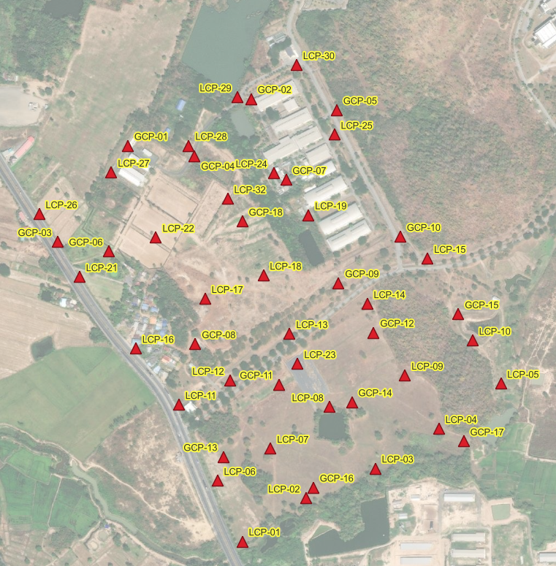**Distribution of Ground Control Point (GCP) and Check Point (CP)**

1. **Aerial Triangulation Result: partial GCP (24 points) vs partial Check Points (24 points)**

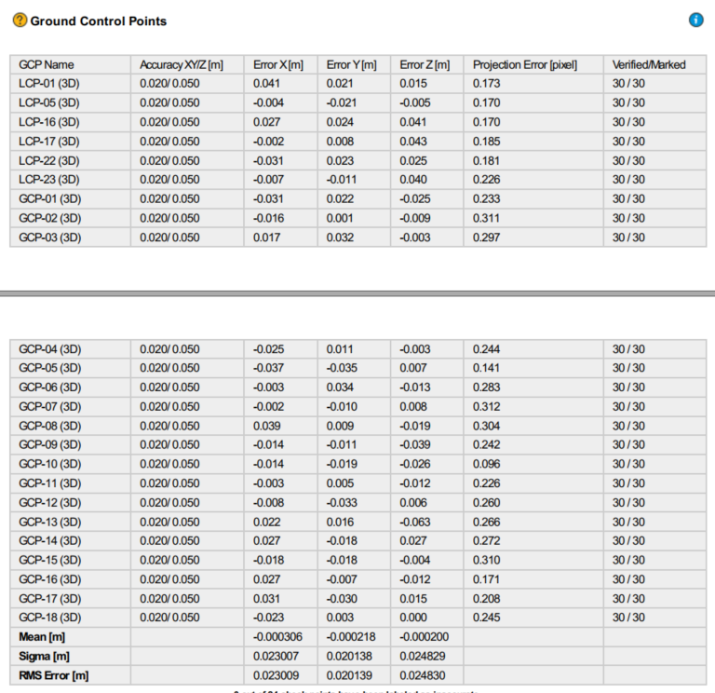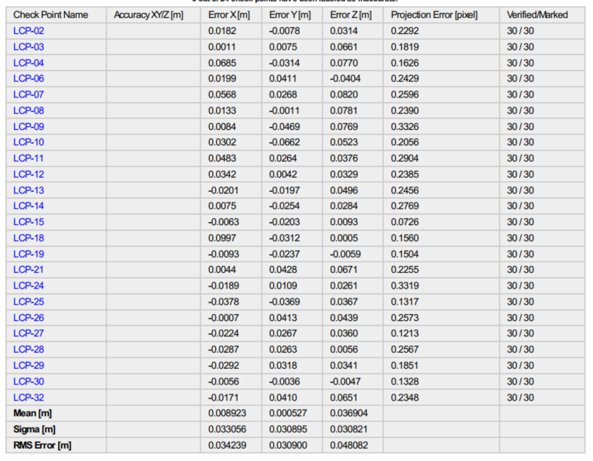

1. **Aerial Triangulation Result: full GCP (48 points)**

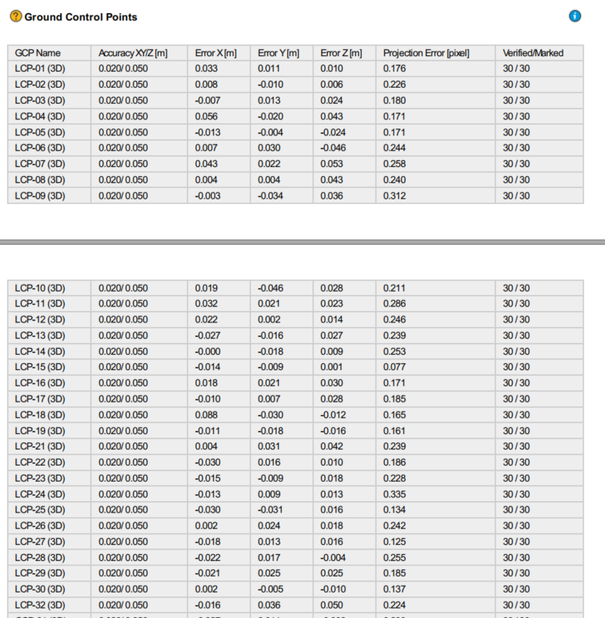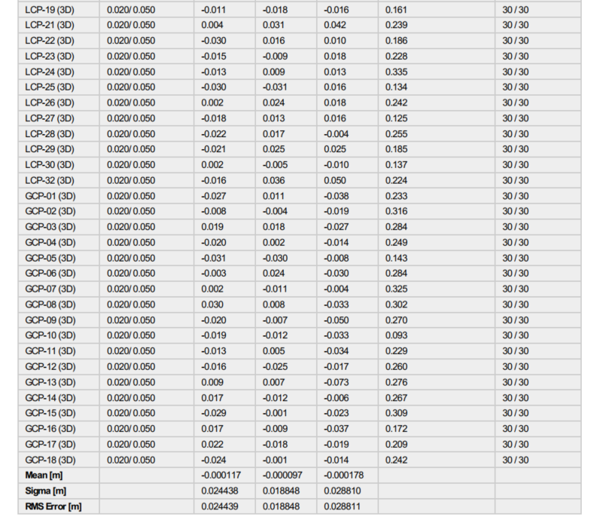

**Evaluation Result:**

|  |  |  |  |  |
| --- | --- | --- | --- | --- |
|  | **Error X** | **Error Y (m)** | **Error Z (m)** | **Projection Error** |
| Criterion | 0.035 m | 0.035 m | 0.065 m | 0.5 pixel |
| Partial GCPs | Badge Tick1 with solid fill | Badge Tick1 with solid fill | Badge Tick1 with solid fill | Badge Tick1 with solid fill |
| Partial CPs | Badge Tick1 with solid fill | Badge Tick1 with solid fill | Badge Tick1 with solid fill | Badge Tick1 with solid fill |
| Full GCPs | Badge Tick1 with solid fill | Badge Tick1 with solid fill | Badge Tick1 with solid fill | Badge Tick1 with solid fill |